Name: ____ANSWERS______________ Score: ___________ / 40 marks

 | Complete the table below that describes the atomic structure of the following:  a a lithium ion  b an aluminium atom  c two isotopes of gallium, 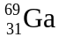  and  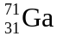 | protons electrons neutrons  3 2 4  13 13 14  31 31 38  31 31 40 | 4
 | Write the electron configuration for the following:  a Ca  b O²⁻  c Ar  d H⁻ | a 2,8,8,2  b 2,8  c 2,8,8  d 2 | 4
 | Name the element in:  a Group 1, Period 3  b Group 15, Period 2 | a sodium  b nitrogen | 2
 | Write the formulae for the following ions:  a acetate (ethanoate)  b rubidium  c sulfide  d lead(II)  e nitrite  f chromate  g hydrogencarbonate  h ammonium | a CH₃COO⁻  b Rb⁺  c S²⁻  d Pb²⁺  e NO₂⁻  f CrO₄²⁻  g HCO₃⁻  h NH₄⁺ | 8
 | Name the following compounds:  a CH₃COONa  b KMnO₄  c Ni(NO₂)₂  d FeSO₃  e AgH₂PO₄  f Co(NO₃)₂  g RbHSO₄  h Mg(OH)₂ | a sodium ethanoate (acetate)  b potassium permanganate  c nickel(II) nitrite  d iron(II) sulfite  e silver dihydrogenphosphate  f cobalt (II) nitrate  g rubidium hydrogensulfate  h magnesium hydroxide | 8
 | Give the formulae of the following compounds:  a strontium iodide  b barium hydroxide  c nickel(II) bromide  d zinc dihydrogenphosphate | a SrI₂  b Ba(OH)₂  c NiBr₂  d Zn(H₂PO₄)₂ | 4
 | Draw and label the structure of a typical metal. | 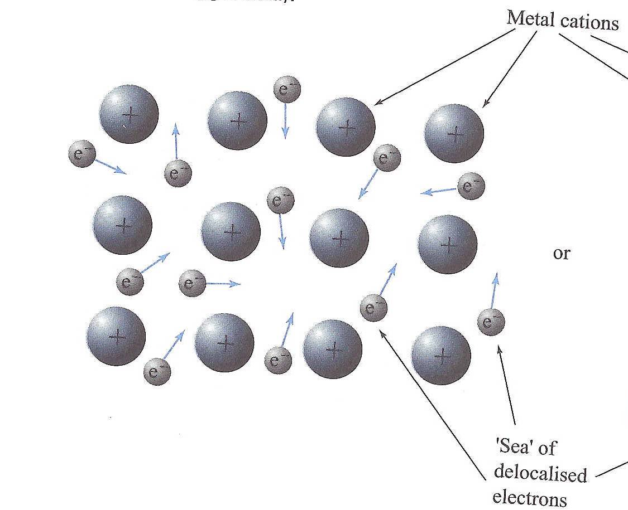 | 2
 | Explain, with regard to bonding and structure, why metals are malleable and ductile. | Metals are malleable and ductile due to the non-directional nature  Positive metal ions can slide past one another without disrupting the metallic bond  Sea of electrons is present between the positive ions before and after the movement | 3
 | Draw electron dot diagrams to represent the transfer of electrons and number of atoms required to produce each of the following ionic compounds.  - Silver oxide from the reaction of silver with oxygen atoms.  - Barium sulphide from the reaction of barium with sulphur. | ∙ ∙  2 [ Ag ] ⁺ [ : O : ] ²⁻  ∙ ∙  ∙ ∙  [ Ba ]²⁺ [ : S : ]²⁻  ∙ ∙ | 4
 | Element A, from group 2, reacts with element B, from group 16, to form a compound. What is the formula of this compound? | A B | 1

